Social Campus Application with Machine Learning for Mobile Devices

Mücahit TÜNEL1 and Şaban GÜLCÜ2

1Necmettin Erbakan University, Konya/Turkey, mucahit.tunel42@gmail.com, Orcid id: 0000-0003-3471-9235

2Necmettin Erbakan University, Konya/Turkey, sgulcu@erbakan.edu.tr, Orcid id: 0000-0001-7714-8861

*Abstract* - In this study, Social Campus Application which can be used on mobile device is explained. Different types of communication have been developed throughout human history. With the rapid change of technology, today's popular communication organs have been the internet and social media. Social media can cause us to spend most of our time on the phone. Social media platforms that offer many options such as quick access to news, instant communication and sharing are indispensables among many of us. This study is about a social media application that is intended to be used among university students. This application was designed which users can be informed of the activity created, open topics and make comments about them, and shop through the market. The application is android-based and contains fp-growth algorithm in the market section. The fp-growth algorithm is an association rule algorithm used to find frequent item sets. The fp-growth algorithm offers the user who supplied together with the analysis of what products the most. The application includes the messaging property between users and this property is based on the technology of firebase, node.js and socket.io. Django and sqlite was used in the web section and the application was developed using the react-native technology.

*Keywords* - Android, React-Native, Fp-Growth algorithm, Social Campus Application, Social Media.

# INTRODUCTION

T

HE ever-increasing ideas of societies such as storing, sharing and using information have led people to new searches. Undoubtedly, one of the most events of 20th century is the discovery of the internet and it introduction to the public service. With the advent of the Internet, people have provided easy, cheap, fast and secure access to information in many areas [1, 2]. In this way, people started to produce new productions. This new communication phenomenon and process, which emerged from the combination of communication satellites and developing technology after the discovery of computer technology, caused our age to be called the "Information Age" [3]. Thanks to the Internet, we can easily send and receive information from one end of the world to the other, and with the advancing technologies in many areas, we can easily do things that we used to have difficult in the past, on the computer. In the information age, information is power and it is necessary to use this power effectively. Even carefully sharing the existing information with someone else is one of the qualities that can increase this power.

The fact that the internet is an interactive medium and that it enables everyone to express their opinions without limitation is beneficial for communication experts, while unlike other mediums, the internet’s duality and suitability for multiple communication draw attention[4]. Providing such a wide area of use and fast communication, the Internet is widely used in universities. With the networks created within the university; Connection via wireless networks is provided to students, academic and administrative staff and employees upon request [5].

Social media is a media system that enables one-way information sharing to be achieved through two-sided and simultaneous information sharing. Social media is a field of application that allows the sharing of information, different views/opinions and experiences by public websites and quickly embeds the internet world in our lives [6]. People can perform many operations such as mutual conversation, messaging and information sharing in two directions, especially thanks to social media applications. Instead of the term social media, which has turned into a very effective structure, terms such as social network, social web, social networking sites are sometimes used both in daily life and in academic literature [7]. Social media meets needs such as communication, entertainment, spending time or following the agenda. But besides these, it can provide an environment for information pollution. Social media, which respond to the social demands of people from all cultures and all walks of life, causes an increase in information sharing and adds a new dimension to socialization [8]. Thanks to social media, polls can be created, people's opinions can be taken, their comments on a subject can be learned, and as a result, new developments and new studies can be realized.

Today, many social media applications have emerged and these applications have played very important roles in communication. Many people around the world use social media applications actively. According to the data, active social media usage in the world is 3.81 billion. According to Statista data, this situation is presented graphically in Figure 1. [9].

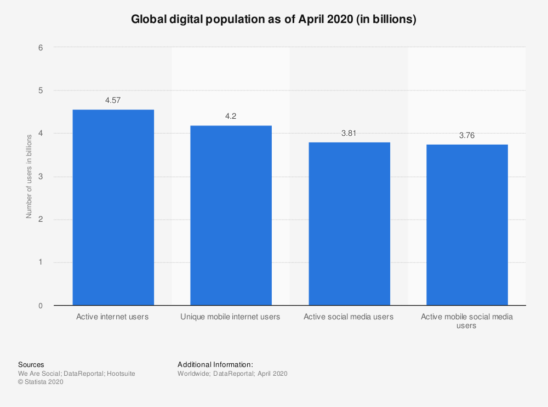

Figure 1: Global digital population as of April 2020 [9].

As you can see, most of the people who use the internet use social media actively. According to Statista data, the most used social media platform is Facebook. This situation is presented graphically in Figure 2 [10].

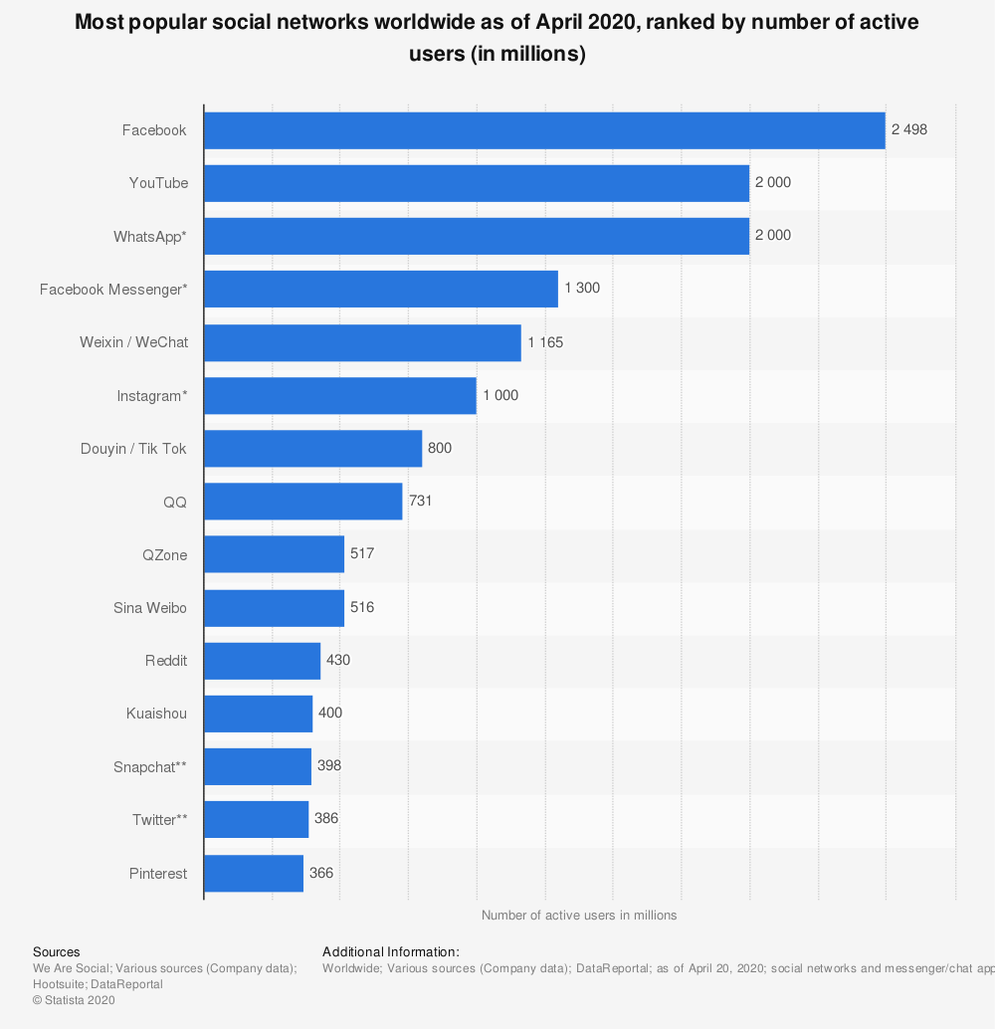

Figure 2: Most used social networks in the world (million)[10].

Social media usage is also very common in our country. It is seen that many people from almost all walks of life use social media. When we look at the rate of social media usage in our country, there are differences in social media usage according to the usage in the world. The Youtube application in our country ranks first with 90% according to the data of the third quarter of 2019. According to Statista data, this situation is presented in Figure 3 [11].

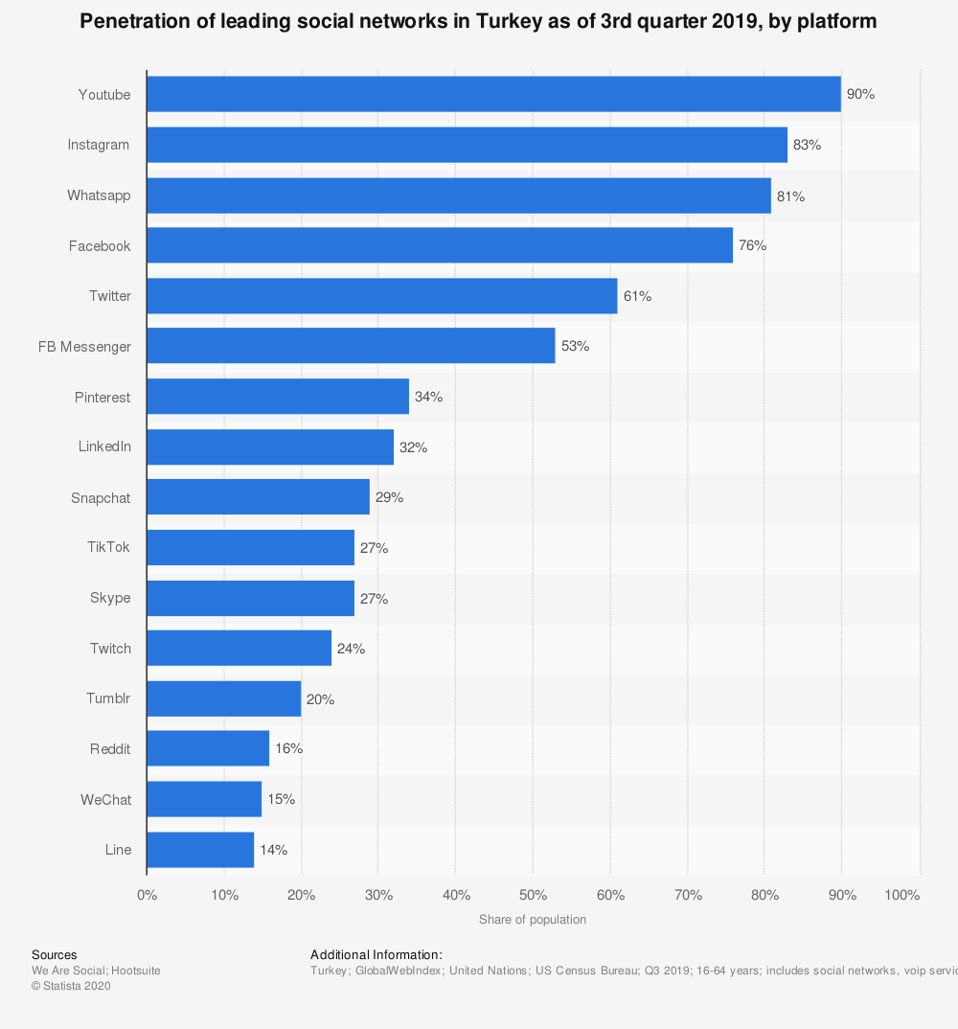

Figure 3: 3rd Quarter Year 2019 in Turkey Social Media Usage Rates [11].

In this study, due to the use of social media so much, an application that includes many features was developed. The social campus application is a social media application that mostly targets university students. It is a social media application where new events can be created and people can be informed, opinions can be received on any subject when there are events such as concerts, trips, and people can reach each other and do business thanks to the market page. However, the people who use the application have the ability to message among themselves. The main purpose of this application is to inform users about the events, to learn their comments and opinions, and to facilitate trading.

Social media applications with many different features are developed for individuals to use according to their needs. There are many social media applications for messaging, sharing or informational purposes. Some of these are given below.

The Uno Social application is an application that allows you to connect with your classmates. It provides access to features such as events, calendars or maps. It offers the services offered on campus. The application has more than 1000 downloads so far.

The Mobile Campus application allows users to reach the online campus on the go. It offers the opportunity to follow active lessons or old lessons. Social groups can be established and notes can be shared. There is also a web version of the application. Features that cannot be done with the mobile application are available on the web page. The application currently has more than 5000 installs.

Facebook is a social media application that aims to enable people to communicate with each other and share information. It has a very wide user area. It is suitable for 13 years and older. Local shopping is provided thanks to the Marketplace. Games can be played inside. Photo, video can be shared and instant notifications can be received. It currently has more than 5,000,000,000 downloads.

WhatsApp is a free instant messaging application. It has the ability to send messages, calls, photos, videos and audio messages. Since the session is always open, instant notifications can be received. It also has the ability to share the instant location. It currently has more than 5,000,000,000 downloads.

The social campus application developed in this study is an application that encourages users to socialize and provide information exchange. It informs us in advance of the events to be organized. By opening topics, opinions of other users are received. It covers everyone, not a specific university community, and is user-friendly. The products that are wanted to be sold with the Market section are delivered to other users by posting ads.

Our study is divided as follows. Detailed information about the subject is given in Chapter 1 and previous studies are listed. The technologies used and the developed system are explained in Chapter 2. Results and outputs are presented in Chapter 3, and the conclusion part is shared in Chapter 4.

# Materıals and Methods

## Association Rule Mining and Fp-Growth Algorithm

Association rule algorithms [12] is a method used to find relationships between variables in large databases. Finds the possibilities of realization according to the data in the database. Predictions about the future are made within these possibilities.

Fp-Growth algorithm is one of the fastest approaches used to find frequency data on the data set [13]. It works fast especially on large datasets. Fp-Growth works with divide and conquer logic [14]. Performs 2 scans on the database. In the first scan, the support values of all objects are calculated. In the second scan, a tree data structure is created. Thus, success can be achieved in large data sets in only two scans. The pseudo code of the algorithm is presented in Figure 4.



Figure 4: Fp-Growth Algorithm Pseudo code [15].

## Used Technologies

**React-Native:**

React-Native [16] is an open source mobile application development library produced by Facebook in 2015. Since it is used with React components, improvements can be made to the web, android and ios, the interface of which is completely created by ourselves. Finally, version 0.63.0 is available. Development is done using Javascript. When the codes are compiled, they turn into a native structure. In React-native, great attention should be paid to the life cycle of the application in order to increase its performance. Because doing important operations such as database connection in the wrong places does not give the desired image by creating instant changes on the application screen.

**Django:**

Django [17] is a high-level Python web application framework. It was first released on July 15, 2005. Finally, version 3.0.7 is available. It has a simple use. It has a very fast, secure and highly scalable structure. Django uses the Model-View-Controller (MVC) structure. It offers an easy development environment thanks to the many methods it offers out of the box. It uses object-relational matching between relational databases. Thanks to serialization processes, data in XML and JSON format can be used. By default, the SQLite database is used.

**Firebase:**

Firebase [18] was founded in 2011 by Firebase Inc. produced by. It is a platform designed for mobile and web application development. Finally, the 7.15.0 version is available for Javascript. It contains many features such as real-time database, cloud messaging, cloud storage. It has a useful architecture to process application data in real-time. Firebase was acquired by Google in 2014 and has been integrated with many Google services.

**Socket.io:**

Socket.io [19] is a javascript library prepared for use in real-time applications. It works with Node.js. Socket.io provides real-time analytics and bidirectional communication. Finally, version 2.3.0 is available. As of version 2.0, Socket.io uses μWebSockets as the underlying WebSocket library.

# Developed System

The social campus application was made to enable users to be aware of the events created, to start a topic and to learn different comments about it, and to facilitate shopping transactions through the market. Add, delete and edit options are available for each section. Thanks to the search page, the desired topic, event or user can be found. Popular topics and market products are added to favorites. Users can message among themselves. It has the feature of blocking each other. When blocking is done, a structure has been created in which old messages can be seen but new messages will not be seen.

The social campus application was developed using the 0.61.5 version of React-Native. Django version 2.2.1 and SQLite database are used. Database operations were performed using the object model with Django. Chat operations were performed using Firebase 6.7.1 version. The connection between React-Native and Django is made using rest technology. Data transfer is made with JSON. Instant communication is provided by using Socket.io version 2.3.0. In the market part of our application, the Fp-Growth algorithm, which is an association extraction algorithm, is used. In this way, you can see which products are mostly examined together with the product you have examined.

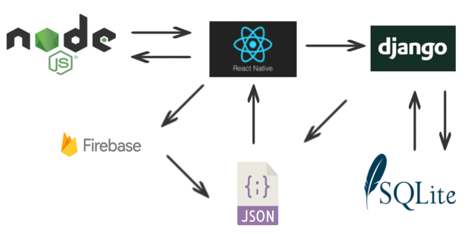

Figure 5: System Architecture.

In order to use the application, you must first register using your gmail address. The user can access the contents after logging in with the registered account. You can list the events, follow the opened topics or create a new topic, enter the market section and contact users for their necessary needs. Interface shapes of the application are indicated in Figure 6, Figure 7 and Figure 8.

The screens shown in Figure 6 are the first screens the user will encounter in the application. First, you have to register and then log in. After login, you will first see the event list screen. Details can be reached by clicking.

Other pages in the main plan are shown in Figure 7. Products are listed on the Market screen. The options at the top are filtering operations. The topics that have been opened can be listed on the second screen. By clicking it, the comments within it can be listed. The last screen is the search screen. There are 3 different search options.

Figure 8 shows the profile page first. Settings are made here. The second and third screens are the section where the event and product details are listed, respectively. Product deletion and editing operations can be performed on the market screen.

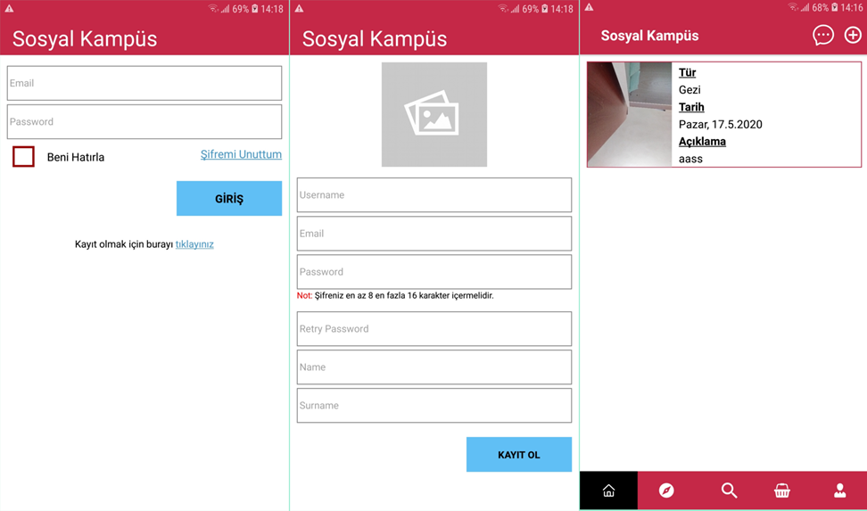

Figure 6: Login-Registration-Homepage Screens.

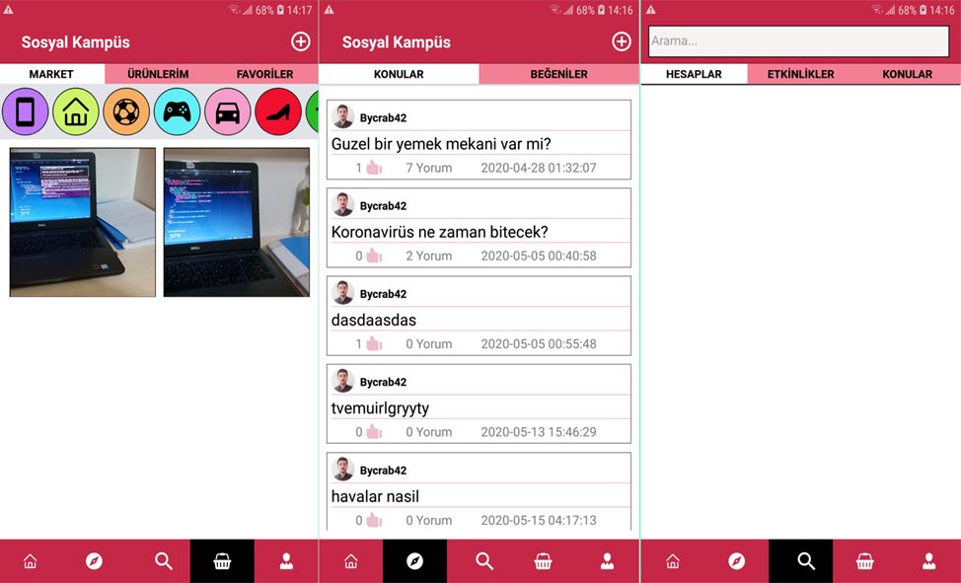

Figure 7: Market-Subject-Search Screens.

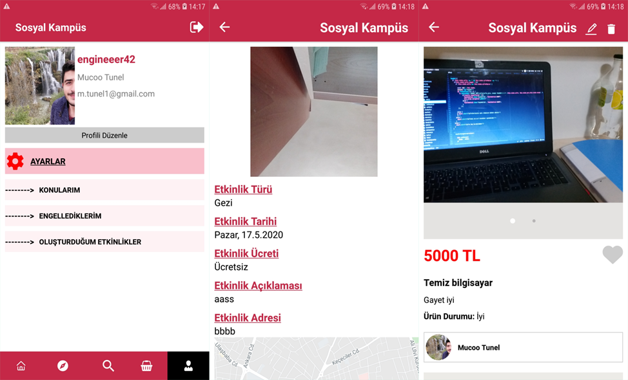

Figure 8: Profile-Event Detail-Market Detail Screens.

# Conclusion

In this study, a social media application was developed to inform the users and to get their comments and opinions, generally covering university students. Creating and publishing an event, creating a topic, listing the topics and receiving comments and posting ads were successfully completed. The Fp-Growth algorithm has been successfully shown to the users, along with the products that users have viewed, along with the most listed products.

The application system is working successfully. In particular, the codes of the application have been optimized more legibly, resulting in high performance in terms of speed. User-friendly design has been created. Thus, users can easily use the application and find the menu they are looking for easily.

Currently developed application works on android devices. It does not work on ios operating system. The next work is to develop the application to run on the ios operating system.

References

1. H. Tutar, M. Yılmaz, Genel iletişim kavramlar ve modeller.(6. Basım) Ankara: Seçkin Yayıncılık, (2008).
2. Ş. Gülcü, M. Tünel, Mobil Cihaz için Apriori Algoritması Tabanlı Kitap Özetleri Uygulaması, Ejons International Journal on Mathematics, Engineering - Natural Sciences, 3 (12), (2019) 46-58.
3. A. Aziz, İletişime Giriş, Aksu Kitapevi, İstanbul, 2008.
4. J. Chipchase, A. Theaker, İnternetin Halkla İlişkiler Alanında Etkili Bir Şekilde Kullanımı, Murat Yaz (çev), İstanbul: Kapital Medya Hizmetleri AŞ, (2006) 357-391.
5. M. Yılmaz, Üniversitelerde halkla ilişkiler: Kurumsal web sayfaları ve sosyal medya uygulamaları üzerine bir değerlendirme, Selçuk Üniversitesi Sosyal Bilimler Enstitüsü, 2015.
6. T. Weinberg, The new community rules: Marketing on the social web, (2009).
7. İ. Sayımer, Sanal ortamda halkla ilişkiler, Beta, 2008.
8. A. Okay, A. Okay, Halkla İlişkiler Kavram Stratejileri ve Uygulamaları, İstanbul: DR Yayınları, 2012.
9. Digital population worldwide, https://www.statista.com/statistics/617136/digital-population-worldwide/, 2020.
10. Global Social Networks Ranked By Number of Users: https://www.statista.com/statistics/272014/global-social-networks-ranked-by-number-of-users/, 2020.
11. Turkey Social Network Penetration: https://www.statista.com/statistics/284503/turkey-social-network-penetration/, 2020.
12. R. Agrawal, R. Srikant, Fast algorithms for mining association rules: Proc. 20th int. conf. very large data bases, VLDB, 1994, pp. 487-499.
13. J. Han, J. Pei, Y. Yin, R. Mao, Mining frequent patterns without candidate generation: A frequent-pattern tree approach, Data mining and knowledge discovery, 8 (2004) 53-87.
14. H. Li, Y. Wang, D. Zhang, M. Zhang, E.Y. Chang, Pfp: parallel fp-growth for query recommendation: Proceedings of the 2008 ACM conference on Recommender systems, 2008, pp. 107-114.
15. G. Grahne, J. Zhu, Fast algorithms for frequent itemset mining using fp-trees, IEEE transactions on knowledge and data engineering, 17(10), 1347-1362, 2005.
16. React-Native: https://reactnative.dev/, 2020.
17. Django: https://www.djangoproject.com/, 2020.
18. FireBase: https://firebase.google.com/, 2020.
19. Socket.io: https://socket.io/, 2020.